PROJECT DESIGN PHASE-II TECHNOLOGY STACK (ARCHITECTURE & STACK)

|  |  |
| --- | --- |
| Date | 2/ 11/ 2022 |
| Team ID | PNT2022TMID05693 |
| Project Name | Project - Smart Waste Management System For Metropolitan Cities |
| Maximum Marks | 4 Marks |

Technical Architecture:

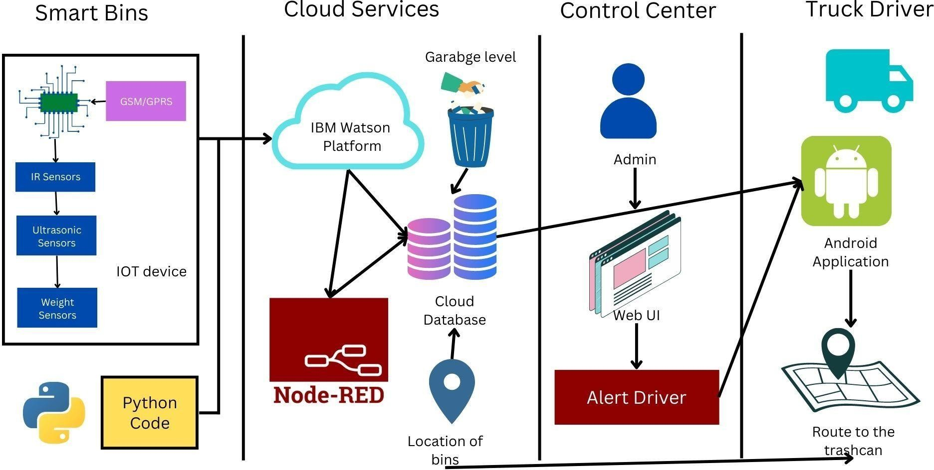

Table-1 : Components & Technologies:

|  |  |  |  |
| --- | --- | --- | --- |
| **S.No** | **Component** | **Description** | **Technology** |
| 1. | Arduino Uno | The Arduino Uno is an open-source microcontroller board based on the Microchip ATmega328P microcontroller. | Arduino programming itself is done in **C++.** |
| 2. | Application Logic-1 | Logic for IR sensor data. | C++/Python |
| 3. | Application Logic-2 | Logic for Ultrasonic sensor data. | C++/Python |
| 4. | Application Logic-3 | Logic for a Weight sensor data | C++/Python |
| 5. | GPRS/GSM | The Arduino GSM shield allows an Arduino board to connect to the internet, send and receive SMS, and make voice calls using the GSM library. | C++/Python |
| 6. | Cloud Sever | Application deployment on Local System / Cloud | IBM Watson IoT Platform, Node Red |
| 7. | Cloud Database | Database Service on Cloud | IBM Watson IoT platform, Cloudant DB |
| 8. | User Interface | How user interacts with application to alert the truck driver. | HTML, CSS, JavaScript , Python etc. |
| 9. | External API-1 | Purpose of External API used in the application to locate the trashcans. | Google Maps Geolocation API |

Table-2: Application Characteristics:

|  |  |  |  |
| --- | --- | --- | --- |
| **S.No** | **Characteristics** | **Description** | **Technology** |
| 1. | Open-Source Microcontroller | Arduino Uno is used to make the IoT device | C++/Python |
| 2. | Security | Encryption/Decryption used for security purpose | GSM/GPRS,Python |
| 3. | Scalable Architecture | New features can be added. | Node Red |
| 4. | Availability | Web application can be accessed from anywhere | IBM Watson IoT Platform, HTML, CSS, JavaScript |
| 5. | Performance | All truck drivers can access the application at same time. | Cloudant DB, IBM Watson IoT Platform |